Title: Deciphering the role of a recently identified domain of human cytomegalovirus fusion protein, glycoprotein B for cell entry

Introduction

Human cytomegalovirus (HCMV) belongs to the Herpesviridae family and is a common lifelong infection, with 60-90%% people thought to be infected (1). The disease burden seen during congenital infection and organ transplantation has made this a high priority pathogen for vaccine development. Previous attempts to develop a vaccine have often included glycoprotein B (gB). The rationale being that it is exposed on the virion surface and critical to viral fusion and entry (2). In follow up studies of a vaccine trial, the Reeves lab discovered protective antibodies to a highly conserved novel antigen domain on gB they termed antigenic domain 6 (AD-6). However, AD-6-specific antibodies were only found in 70% of vaccine recipients and rarely (<5%) from natural infection. It is hypothesised that because AD-6 is buried internally within the gB homotrimer (*Figure 2a*) and only transiently exposed during the change in protein conformation from pre-fusion to post-fusion, there is insufficient time during natural infection for antibodies to be generated against it. The vaccine contained monomeric and trimeric recombinant subunits of gB, that they hypothesise exposed AD-6 to prime AD-6 specific protective antibodies that were boosted upon challenge with the virus (2).

To understand the importance*,* of AD-6 in gB function *Gomes et al,* 2023 also proved AD-6 polypeptide added alongside the virus to a cell-layer inhibited HCMV infection in fibroblast but not epithelial cell lines (2). Furthermore, they demonstrated AD-6 has near-perfect conservation at the amino acid level with 96.1% identical sites in an analysis of 390 HCMV genomes (2). One hypothesis was exogenous AD6 could compete with virion gB for an unidentified target of AD-6-blocking infection. Unpublished in-silico analysis suggests that an AD-6 or AD-6-like domain can be found in many viral fusion proteins including other herpesviruses such as Herpes simplex virus 1 (HSV-1). Thus during the rotation we sought to investigate the genetic and functional conservation of AD-6 between HCMV and HSV-1, and in particular if HSV-1 AD-6 can also inhibit HSV-1 infection of cells as described for HCMV. Due to the relatedness of the viruses and AD-6 peptides, we also want to investigate if HSV-1 AD-6 and HCMV AD-6 are capable of cross inhibiting infection.

Methods

**Peptide inhibition assay**

Firstly, the peptides were dissolved into DMSO to a concentration of 40mg/mL and titrations were performed to test the volume of DMSO and virus (strains HSV-1-VP26GFP, HCMV-TB40E-GATA2-mCherry.) That would be well tolerated by the cells and cause around 50% infection in both the spontaneously arising retinal epithelial cells (ARPEs) and Human Foreskin Fibroblasts (HFFs) cell lines. We found that with 4% DMSO, the following virial volumes were optimal (*Table 1*).

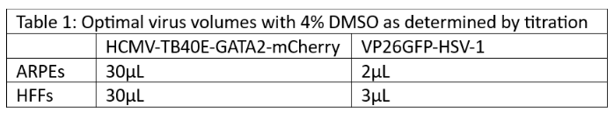

Both cell lines were seeded into a 96-well plate with DMEM overnight at 37oC 5% CO2 until confluent. In a separate dilution plate 100uL/well of virus-peptide mix was pre-incubated for 1 hour before added to the cell-layer. Starting with a final concentration of 100mM the AD-6 peptide was 1:2 serially diluted 6 times and the appropriate volume of virus as determined by titration was added to each well. Included in the layout were wells for cells only, virus-only and virus + DMSO controls for normalisation. The virus-peptide mix was incubated with the cells at 37oC, 5% CO2 for 1-hour post infect (hpi) for the HSV-1 and 3 hpi for HCMV, replaced with 100μL of media and incubated again at 37oC 5% CO2 until 18 hpi for HSV-1 and 24 hpi for HCMV. Post incubation, the plates were washed with 100uL/well of PBS before fixed with 100uL of ice-cold 100% ethanol and kept at -20oC for 30 minutes. The ethanol was removed, and the plate was washed.

HCMV-infected cells were stained with a primary antibody for immediate early protein, an abundant surface marker of HCMV, washed and then stained with a secondary and cell stain Hoechst. HSV-infected cells due to their GFP tag were just stained with 100uL/well of Hoechst stain. The plates were washed with 100uL/well of PBS and then replaced with another 100uL of PBS for imaging.

The plates were imaged with fluorescent microscopy by Hermes WiScan (IDEA Bio-Medical) instruments and the percentage infection was calculated by MetaMorph software (Molecular devices).

Results

**Sequence alignment**

Sequence alignments of AD-6 across cytomegalovirus species and HSV-1 (*Figure 1*), demonstrated a high-level of conservation, especially between the more closely related cytomeglaviruses viruses in other primates, e.g. 92% between amino acid conservation between HCMV and Chimpanzee CMV AD-6. However, HSV-1 AD6 showed less conservation with HCMV only around 30% of amino acid residues, but an additional 20% of residues were from related amnio acids groups e.g. L19I and D13E. Furthermore, when the amino acids are identical between HSV-1 and HCMV this is often maintained across all species such as residues 2 and 4 (*Figure 2a*). Conserved residues were clustered at the beginning and end of the coil-coil and non-structural regions (*Figure 2b*).

**Peptide inhibition**

Confirming findings of *Gomes et al,* 2023 we showed that the highest concentration of 100mM of HCMV AD6 peptide was able to inhibit HCMV infection of fibroblasts but not epithelial cells. Despite the conservation between HSV-1 and HCMV AD-6, HCMV AD-6 polypeptide was unable to inhibit HSV-1 infection (*Figure 2a*).

In contrast, HSV-1 AD6 had a much more potent inhibitory effect and at the highest concentration was able to inhibit HSV-1 infection in both epithelial cells and fibroblasts, and additionally, showed much stronger cross-reactivity and was able to reduce HCMV infection in both cell lines (*Figure* 3c).

At the lowest concentration, all inhibitory action was lost with the exception that HSV-1 AD-6 still showed inhibition to HSV-1 infection in HFFs(*Figure 3b*). For most conditions where inhibition was shown, there was also a clear trend of increasing infection as the concentration of AD-6 was reduced *Figure 3c*.

Discussion and conclusions

The data confirm HCMV AD-6 polypeptide was able to inhibit HCMV infection of fibroblasts but not epithelial cells. We now show that HSV-1 AD-6 polypeptide was able to potently inhibit infection of both epithelial cells and fibroblasts by HSV-1 and also displayed strong cross-reactivity, inhibiting HCMV infection in both cell types. Interestingly, HCMV AD-6 was never able to inhibit HSV-1 infection when used at similar concentrations. One possible interpretation maybe that AD-6 shares critical interactions in the fusion process in both viruses but, potentially, that HSV-1 AD-6 has a higher affinity for the target and outcompetes HCMV AD-6. We hope to repeat the results so we can run powered statistical analyses to confirm the trend we have described.

The pattern of inhibition creates lots of potential research regarding the mechanisms the viruses use to fuse with the cells. Both HSV-1 and HCMV infect fibroblasts via the plasma membrane. To do this, HCMV forms a complex of gB/gH/gL differing from HSV-1 which additionally uses gD to act as a recruiting factor (3, 4). However, to infect epithelial cells HCMV utilises an endosomal route of entry, and this requires a pentamer of gH/gL/UL128-130-131 (3) and gB fusion from within the endosome – thus why HSV AD-6 can block both but HCMV AD-6 just fibroblasts remains unclear A key piece of information will be understanding binding partners of AD-6s from different herpes viruses. One approach would be to run His-tag chromatography and SPERO resonance experiments to identify the target that AD-6 is binding and the mechanism HSV-1 AD-6 uses to inhibit HCMV infection of epithelial cells that HCMV-AD6 is unable to do? This key information allows the development of better HCMV and HSV-1 therapeutics and vaccines through better understanding the role of domains within proteins essential for viral entry.

References

1. Griffiths P, Reeves M. Pathogenesis of human cytomegalovirus in the immunocompromised host. Nat Rev Microbiol. 2021;19(12):759-73.

2. Gomes AC, Baraniak IA, Lankina A, Moulder Z, Holenya P, Atkinson C, et al. The cytomegalovirus gB/MF59 vaccine candidate induces antibodies against an antigenic domain controlling cell-to-cell spread. Nature Communications. 2023;14(1):1041.

3. Wang D, Yu Q-C, Schröer J, Murphy E, Shenk T. Human cytomegalovirus uses two distinct pathways to enter retinal pigmented epithelial cells. Proceedings of the National Academy of Sciences. 2007;104(50):20037-42.

4. Agelidis AM, Shukla D. Cell entry mechanisms of HSV: what we have learned in recent years. Future Virol. 2015;10(10):1145-54.

Acknowledgements

Thank you to the Reeves Lab for hosting me and especially Anastasia Lankina and Matthew Reeves for their assistance, training, and guidance with the project.

With thanks to the MRC who funded the rotation, grant code: MR/W006774/1

Figures

Figure 1: Sequence alignment of AD-6 across Cytomegaloviruses viruses and Herpes Simplex Virus 1

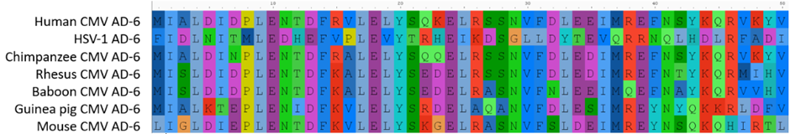

10

20

30

40

50

Figure : Sequence alignment of AD-6 across cytomegalovirus (CMV) and Herpes Simples Virus 1 (HSV-1) using reference sequences from GenBank and assembled using AliView. (Reference genomes taken from the NCBI GenBank database HumanCMV_gB_AY446894.2, HSV-1 NC_001806.2_UL27_YP_009137102.1, ChimpCMV_gB_NC_003521.1 RhesusCMV_gB_MZ517254.1, BaboonCMV_gB_MT157322.1, GuineaCMV_gB_NC_020231.1, MurineCMV_gB_NC_075725.1

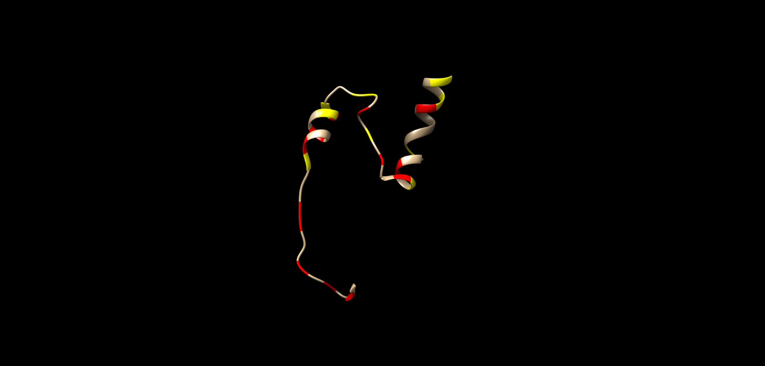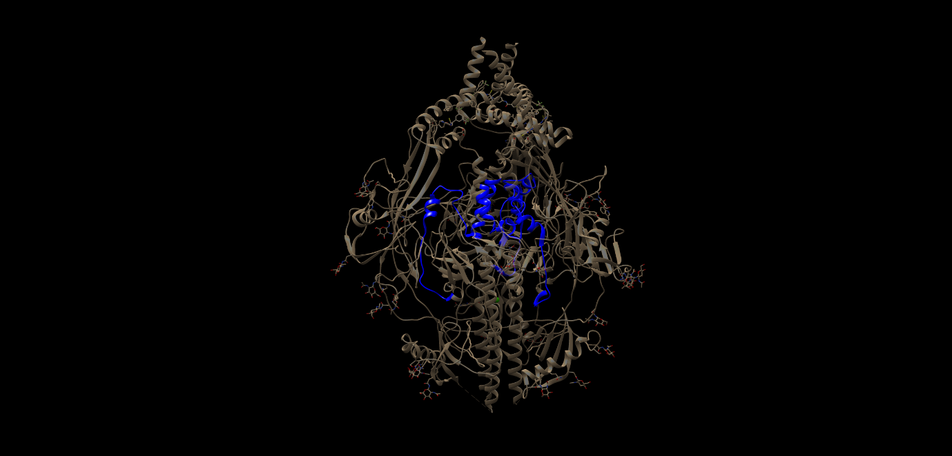

2a

2b

Figure **A)** Human Cytomegalovirus (HCMV) glycoprotein B (gB) trimer in a prefusion conformation with the antigenic domain 6 (AD6) domains from each monomer of gB highlighted in blue. **B)** A HCMV AD6 monomer to demonstrate regions of conservation between HCMV Ad6 and Herpes simplex virus 1 (HSV-1) AD6. Identical amino acid residues between HCMV + HSV-1 AD6 coloured in the red and similar amino acid residues from the same group in yellow. Images created using PDB 7DKP in UCSF Chimera, developed by the Resource for Biocomputing, Visualization, and Informatics at the University of California, San Francisco, with support from NIH P41-GM103311.

Figure 2: HCMV AD-6 structure and conservation with HSV-1 AD6

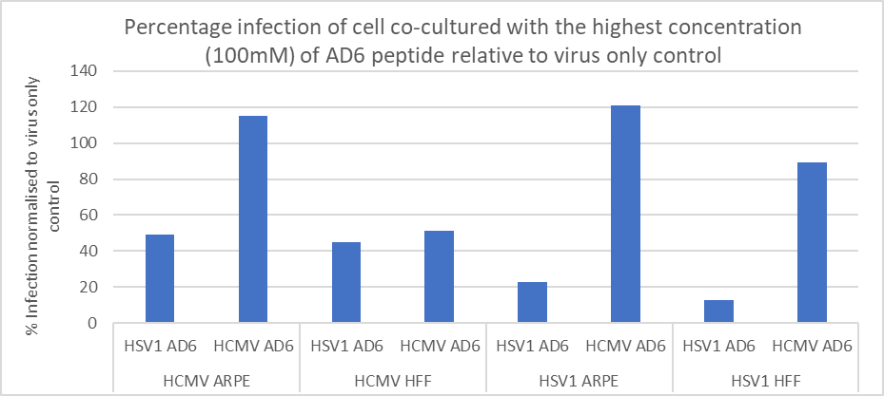

3a

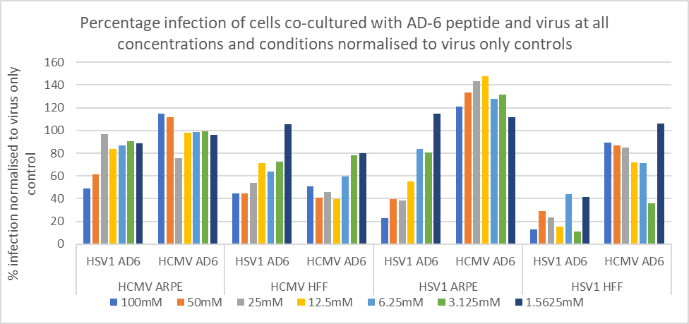

3c

Figure : Bar graphs shwoing the percentage infection of both cells lines spontaenosult arisinf retinal epithelais cells (ARPEs) and Human foreskin fibroblasts (HFFs), by both human cytomeglavirus (HCMV) and Herpes Simples Virus 1 (HSV-1) , when co-cultured with HCMV and HSV-1 antigen domain 6 (AD-6) to measure its inhibitory effect on infection. All percentages have been normalised to a virus-only control. **A)** Percentage infection at the highest concentration of AD-6. **B)** Percentage infection at the lowest concentration of AD-6. **C)** Percentage infection at all concentrations of AD-6.

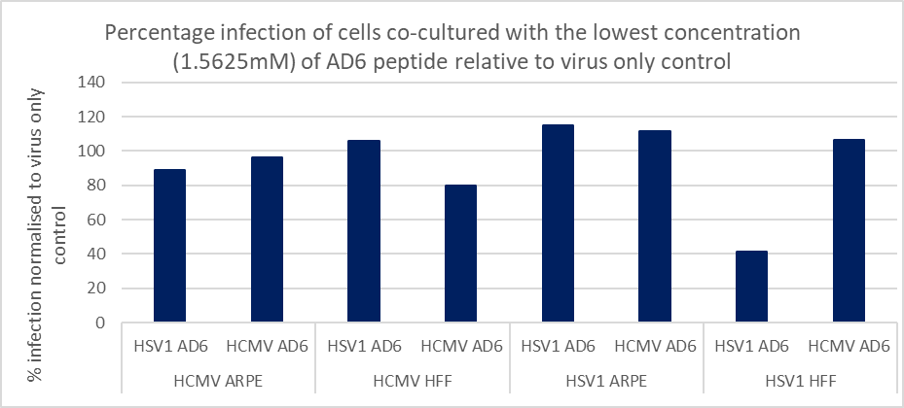

3b

Figure 3: Bar graphs to showing the inhibitory effect of AD-6 on HSV-1 and HCMV infection of fibroblast and epithelial cells

Reflection on Rotation 1

I learned and achieved a lot throughout this rotation, my proudest achievement was producing work that my supervisor requested I submit as an abstract which was since accepted for a talk at the microbiology society. This is a slightly scary proposition as I am new to the field and haven’t had the time to get my background reading to the point where I feel sufficiently ready to answer questions, however, I have time between now and then to work on this and I feel the conference overall is a great opportunity to build confidence and a network that I can bring forward with me during my the rest of the PhD.

I was warmly welcomed by everyone in the Reeves Lab, it is a friendly social lab with lots of really interesting current and future research avenues across a wide range of questions giving lots of scope for me to flexibly move, making it a group I will be happy to consider returning to after my rotations.